BIO 215Malheur Natural History Studies-Spring 2020 Journal
Electronic Field Journal Guidelines (150 points) More than one exam
Your field journal should be viewed as a journal over four weeks of nature. If it helps, consider yourself a field naturalist on route through the state and your notes and impressions are all that your readers will have to catch of glimpse of the natural wonders you have experienced. To keep yourself on track, consider the following guidelines as you prepare your entries. You need 6 entries over 3 weeks and a final reflection that summarize your overall impression of being outside!

Go outside and spend at least 20 minutes on each entry!
This is Homework!

Here is a link to all the Portland Parks! Or find one near you in Guam, Hawaii or Brazil!

- Begin each entry with the date and time.
- Note the location, with county and state, country if you not in the US,
- Most Cell phones will give you a Latitude and Longitude.
- 4 Photographs should be included per entry (Broad Scenery, a closer look at habitat, a bird photo (can be far away or slightly blurry), and some type of plant/flower
- Note any other sights, sounds, observations that you consider significant or particularly interesting.
- Record your own thoughts and feelings as you explore

- As you type it up and import the photos try to identify the bird and the plant/flower!

Journal Entry

April 15, 2019 1:30 pm Slightly overcast with a few sun breaks, wind 14 kph
Location: Painted Hills, John Day Fossil Bed OR
Latitude: 44.6615 Longitude: -120.2731
Broad Scenery:
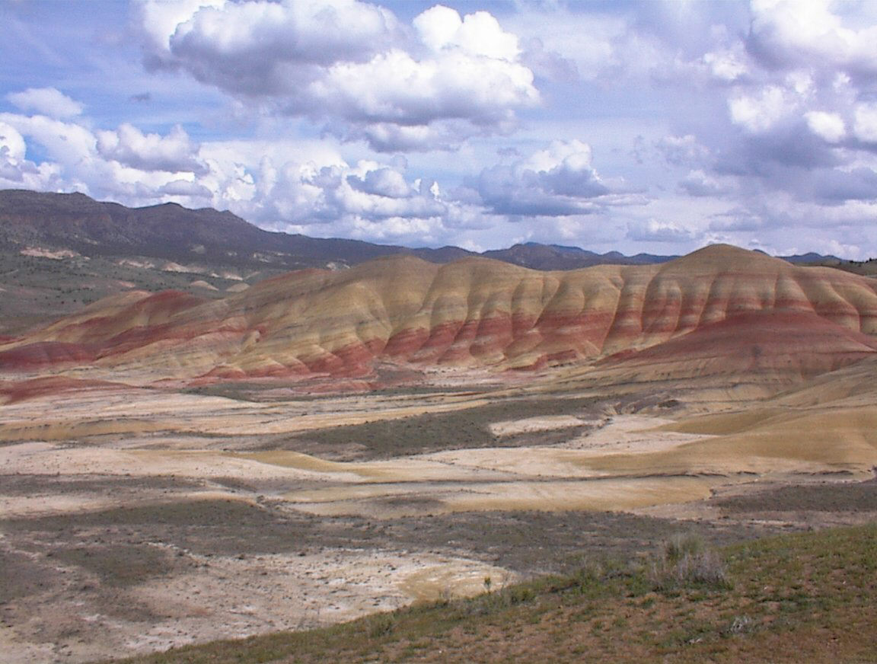
This was at the Painted Hills, it was very windy and very quiet the only to hear was bird song, no traffic, jets, people or city noise.
The clay-soils were red, light yellow, tan, with streaks of black. This is part of the John Day National Monument.

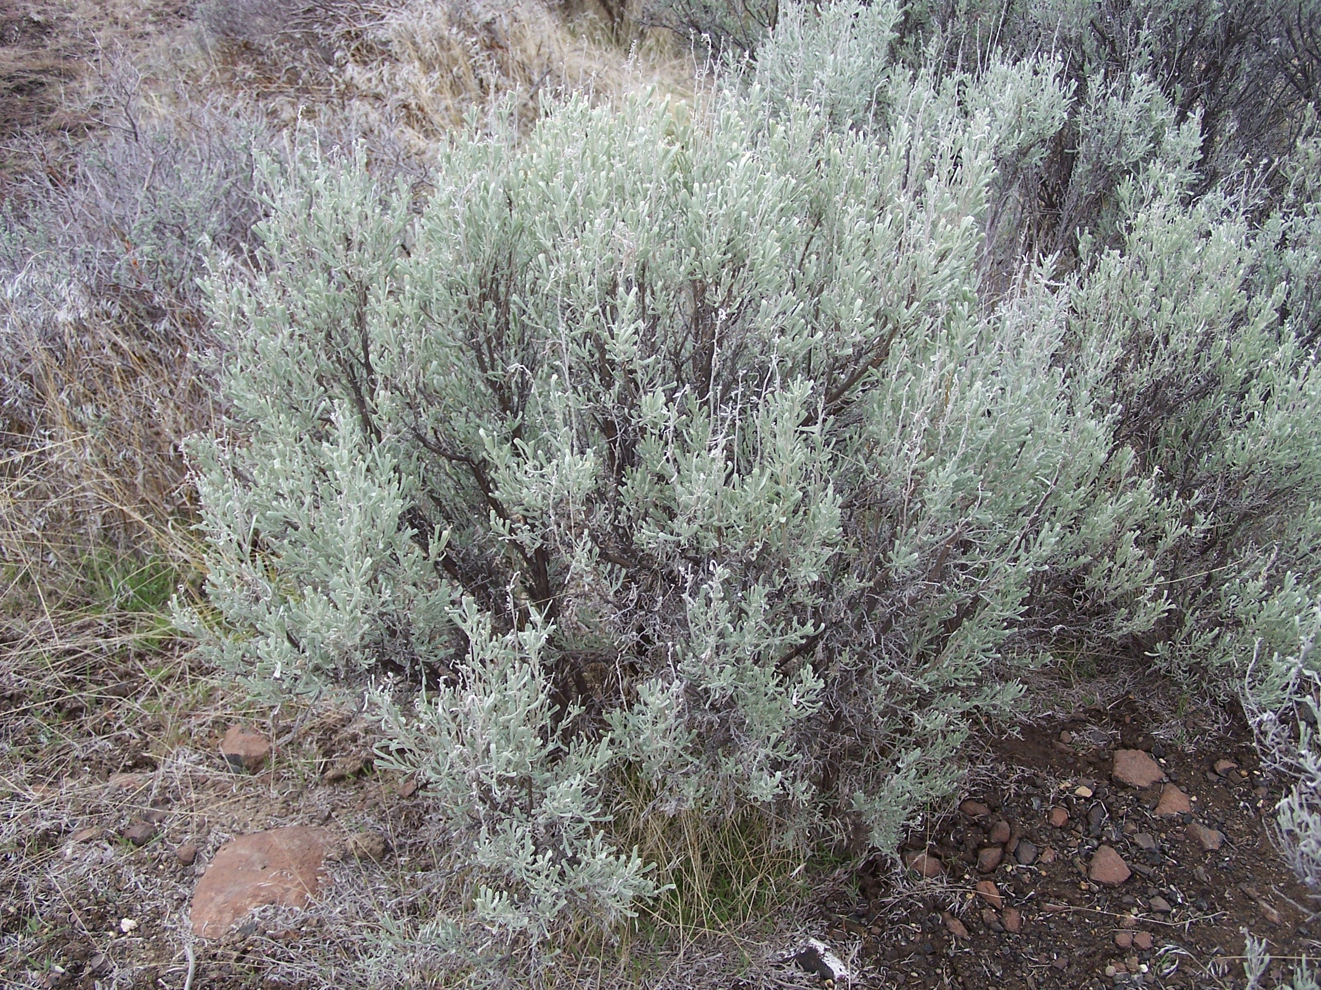Closer look at habitat:

It was super dry here. There was only one lone juniper near the parking lot entrance.
There was sagebrush here but there was like 60 cm distance between each plant with open space.
I did also see a Western Harvester Ant mound.

Bird photo:
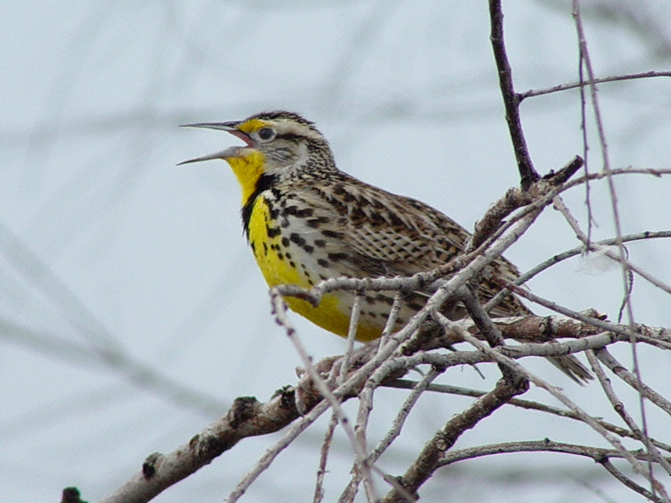
This bird kept making the same six note call. It took a while to find it even in the sparse growth. It had a brown back it was not until it turned around did is see the yellow chest with the black V pattern.

I looked for it on the internet and found it was a western meadowlark.
The state bird of Oregon!

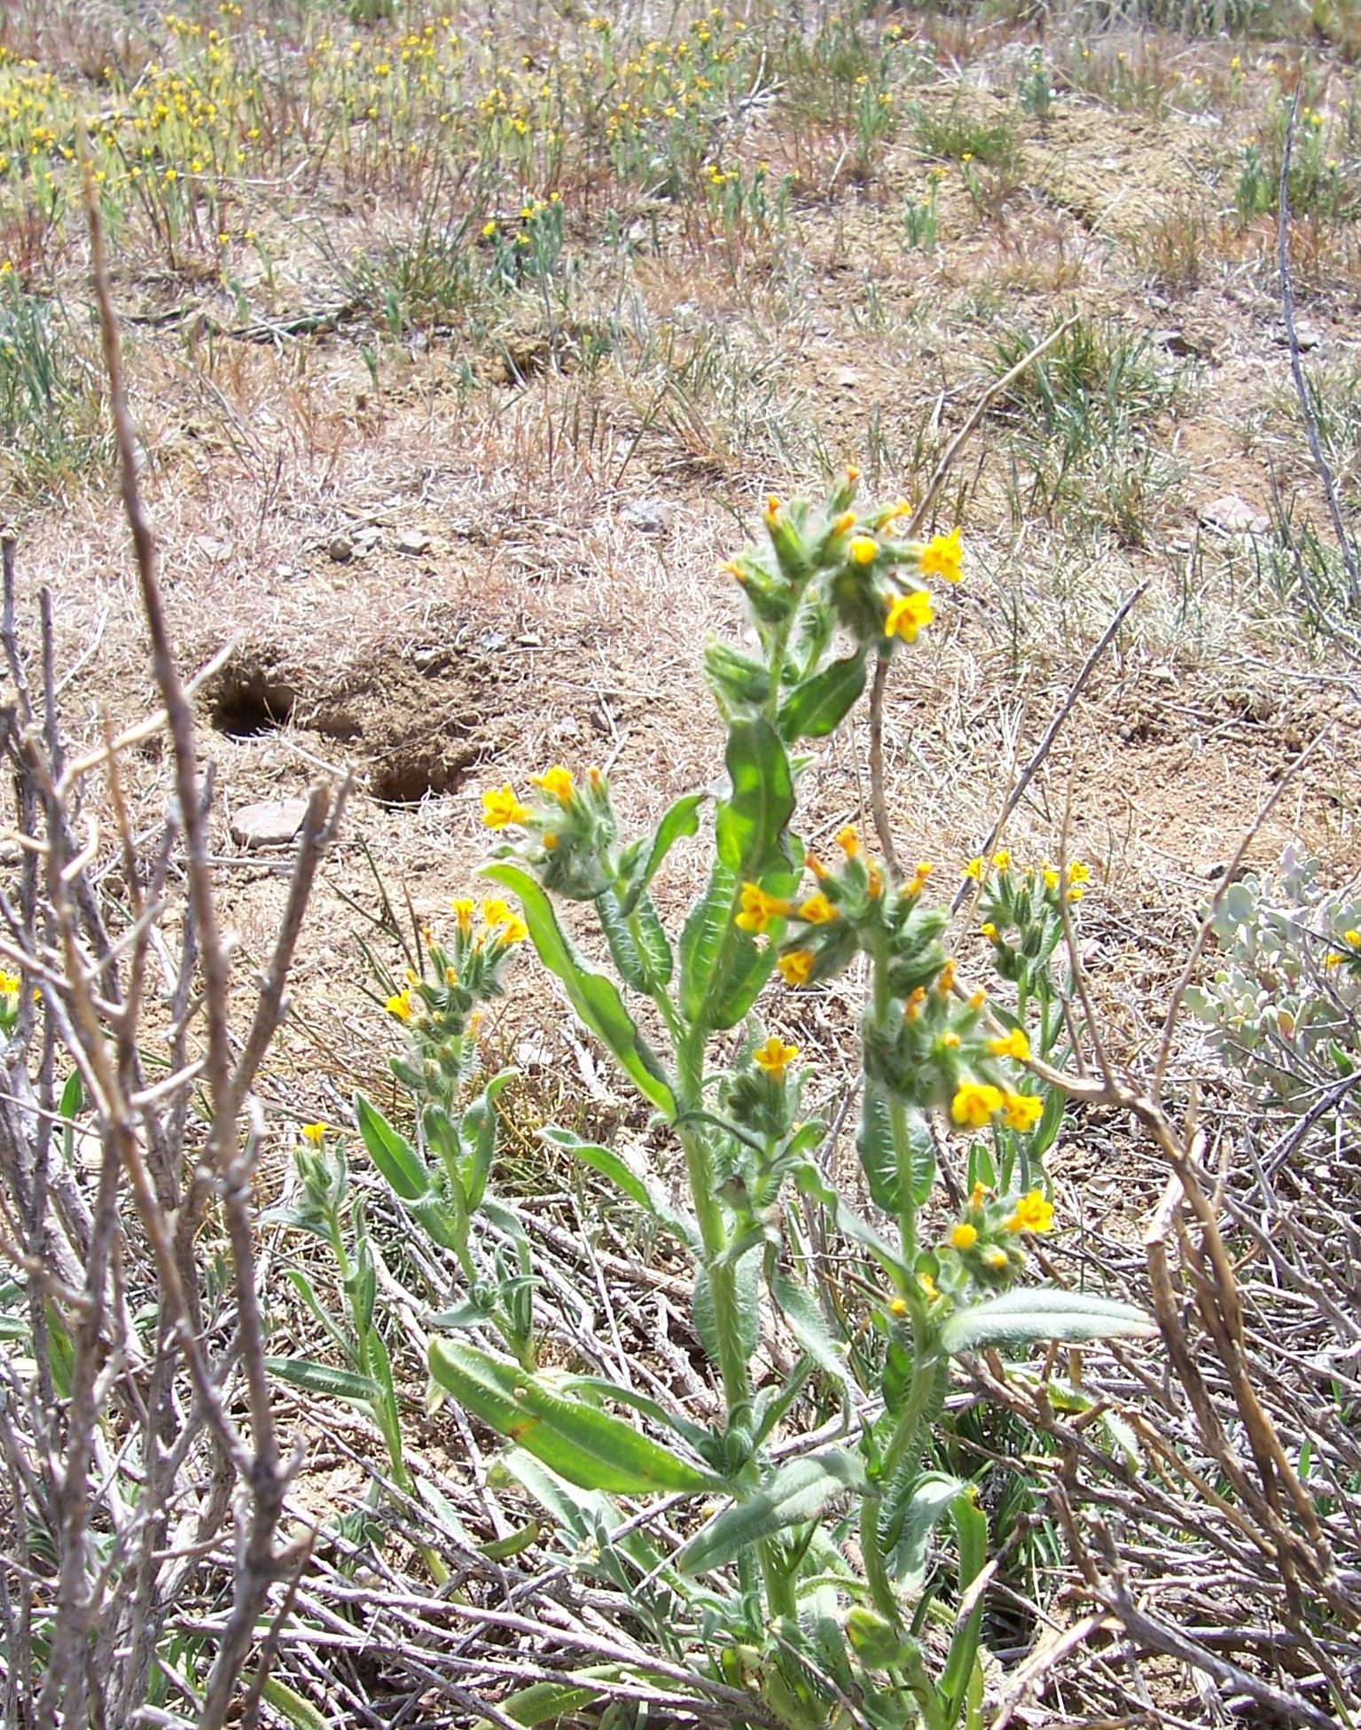Plant or Flower:

This was a medium size wildflower about 15 cm tall.
The flowers were yellow, and the plant was covered with fuzz.

After searching I found it was a Fiddleneck!
Amsinckia intermedia

At least that is what I thought it was.

Final Thoughts:
This is a great place so peaceful. It was just nice to sit and “be” I know this is part of a class assignment, but I have had worse. I may have even got at tan.
I wish the trip would have happened, but it did not so I will make the best of nature around me.

